Leader’s monthly bulletin – November 2023
Welcome to the latest edition of my monthly bulletin, which aims to keep councillors, officers, and town and parish councils up to date on the month’s main news stories and any emerging issues from the district. Caroline

Storms Babet and Ciarán
On Friday 20 October, East Suffolk was badly affected by Storm Babet which resulted in serious flooding in parts of the district, and lead to the declaration of a major incident in Suffolk.
East Suffolk Council and East Suffolk Services have been working tirelessly to support communities as they seek to recover from the incident, with Framlingham and Wickham Market having been seriously impacted.

In the immediate aftermath and for the days that followed, teams were on hand offering housing advice, as well as clearing and cleansing work. East Suffolk Services provided vehicles and staff to assist with the clearance of houses and businesses in Framlingham, and will be providing additional support and resources, for however long is required, to all affected areas. I would like to thank everybody who assisted those that suffered flooding and continue to assist.

Residents were asked to make the Council aware of issues that were causing concern and urged anyone seeking assistance to get in touch. The Council’s ‘out of hours’ telephone number took many calls and for any future incidents, members are asked to encourage residents or communities seeking help with housing and cleansing to call 0333 016 2000 during normal working hours or 0800 440 2516 out of hours.

A rolling page of information remains available on the Council’s website, with further updates added last week relating to Storm Ciarán. The page contains a wealth of information which residents may find helpful, including contact details for energy providers and other agencies.

Our Direction
A survey seeking the views of local people on the Council’s new Strategic Plan, ‘Our Direction 2028’ has now closed, with the plan being presented to Cabinet on 7 November.

‘Our Direction 2028’ proposes ‘to promote a bright, green, open, free, and fair future for all East Suffolk’ and is accompanied by four key themes which would form the basis of the Council’s approach to service delivery and direction across the next four years. The four themes will be Environmental Impact, Sustainable Housing, Tackling Inequalities, and a Thriving Economy.

Flood walls complete
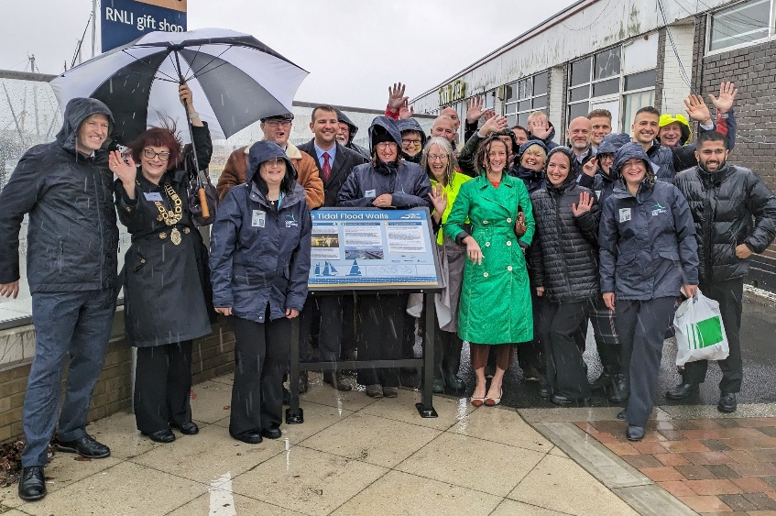
On a very wet day in October, I joined Peter Aldous MP for Waveney and community representatives, businesses, invited guests and local students to mark the completion of the first phase of the Lowestoft Flood Protection scheme – the tidal walls.

A new information board was unveiled on the South Pier by Peter Aldous, myself and Karen Thomas (Head of Coastal Partnership East).

The 1.5km of flood defences have been built in key locations impacted by 2013 East Coast Tidal Surge as part of the wider Lowestoft Flood Protection scheme. Flood walls, demountable defences and flood gates have been built along Hamilton Road, Waveney Road and Station Square. Glass-topped flood walls have been built around the Royal Norfolk and Suffolk Yacht Club and the South Pier to maintain views across the marina.

The tidal flood walls are an important part of the overall flood protection of Lowestoft, designed to work in conjunction with a 40m tidal barrier, proposed to be located on the seaward side of the Bascule Bridge. East Suffolk Council has recently submitted an application for a Transport and Works Act Order to progress the tidal barrier scheme.

Once complete, the Lowestoft Flood Protection scheme will better protect over 1,500 homes and 800 businesses from the risk of tidal flooding.

I would like to thank former East Suffolk councillor David Ritchie for leading on this project in the initial stages to get us to this point.
Seashore village complete
Work has reached completion on a new seaside development of beach huts and landscaped public greenspace in Felixstowe. The new Seashore Village attraction features 27 traditional-style timber beach huts provided by East Suffolk Council.

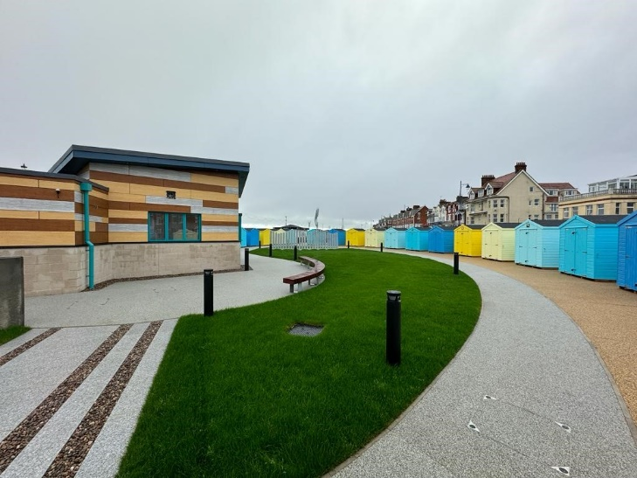
Completion of the Seashore Village brings to fruition a wider regeneration project on land between Sea Road and The Promenade – with a neighbouring activity park, featuring climbing walls, sports equipment and games, opening in July.

East Suffolk Council has worked with Scott Beckett Estate Agents for the sale of the new beach huts, primarily set around a central ‘fish-shaped’ lawn, created by Plaice Design architects.
Final preparations now proceed on the hireable ‘pod style’ beach chalets, designed with accessibility and inclusivity in mind. The building has an adaptable form and can be configured for use as five single accessible chalet spaces or opened-up for larger groups, providing a flexible and access-friendly facility.

£4.2m to transform brownfield land
A Government grant worth more than £4.2million has been awarded to East Suffolk Council to help transform brownfield land in Lowestoft into much needed future housing.

The £4,203,800 grant is part of the second phase of a £180m Brownfield Land Release Fund designed to unlock sites across the country to make way for more than 6,000 new homes.

The funding will help cover the cost of land remediation at the former Sanyo and Survitec manufacturing sites located on the south side of Lake Lothing, Lowestoft, in an area known as Kirkley Waterfront.

£900,000 investment for historic Town Hall
A project to restore and revitalise Lowestoft’s historic Town Hall has received a further funding boost thanks to a £900,000 investment by East Suffolk Council.

The funding will go towards a project to transform the vacant High Street building into a multi-functional community space, containing a Heritage Gallery, café, community event space and town council offices.

Last month, Cabinet members agreed a request from building owner and project leader, Lowestoft Town Council, for a financial contribution towards the redevelopment, which forms part of the Lowestoft Town Investment Plan and the Towns Fund programme.

East Suffolk Council has already provided support in developing the project plan and bidding for additional external funding, which included an allocation of £2million in Towns Fund investment as part of the overall £24.9m Lowestoft’s Town Deal awarded by the Department for Levelling Up, Homes & Communities in 2022.

Last month, the project received another major £3,257,512 funding boost from The National Lottery Heritage Fund as part of a £12.2m investment to help restore 12 historic buildings nationwide.

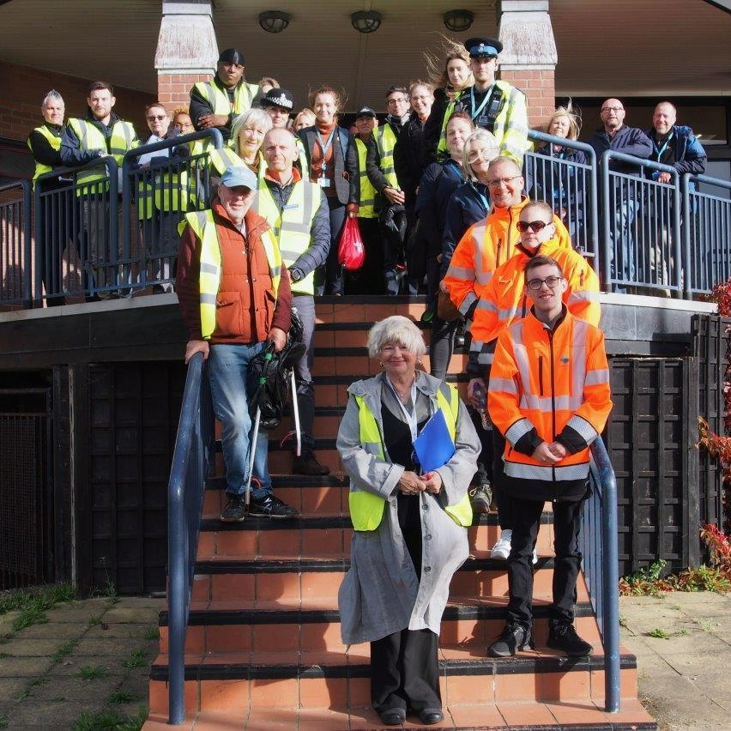
Multi-agency day of action in Felixstowe
On 17 October, our Licensing and Environmental Protection teams took part in a multi-agency day of action to detect and deter crime and anti-social behaviour in Felixstowe.

Officers were joined by members as well as counterparts from Suffolk Constabulary, Suffolk Fire and Rescue Service, Suffolk County Council’s Trading Standards team and Felixstowe Town Council for the operation.

Organised by the East Suffolk Community Safety Partnership and funded through the Enabling Communities Budget, the impact event saw partner agencies conduct a series of checks and inspections aimed at strengthening community safety through collective activity.

Safe Suffolk Renters
Suffolk’s five district and borough councils are delivering a ground-breaking project aimed at improving the experience and environment for landlords and tenants in the private rented sector.

Called ‘Safe Suffolk Renters’, this multi-faceted initiative is designed to create a better understanding of the pressures and problems in the sector, and to improve standards, particularly in the worst private rented homes in the area. To achieve this, the project team will consult widely with tenants, landlords and stakeholders in the county.

The project is already speaking with key stakeholders and is also staging a landmark conference for private sector landlords at the University of Suffolk in Ipswich. Engaging for a Better Future will bring together landlords, representatives of member associations and industry professionals later this month.

Property owner fined
A Lowestoft man has been ordered to pay £4,400 for breaching planning regulations by using the grounds of a residential address to store building materials.

Derrick Crews was due to attend Suffolk Magistrates’ Court on 23 October to face three charges of failing to comply with an enforcement notice issued by East Suffolk Council.

Coastal adaptation document adopted
A document providing planning guidance for coastal communities in East Suffolk, Great Yarmouth and North Norfolk has been formally adopted.

The joint Coastal Adaptation Supplementary Planning Document (SPD), prepared in partnership by East Suffolk Council, Great Yarmouth Borough Council, North Norfolk District Council, the Broads Authority and Coastal Partnership East, supports the implementation of Local Plan policies relating to the coast from Holkham in North Norfolk to Felixstowe in East Suffolk.

Transport and Works Act Order application
East Suffolk Council has applied for a legal authorisation order required to progress the Lowestoft Tidal Barrier project.

Proposals for a new tidal barrier were developed by the Council as part of the wider Lowestoft Flood Protection scheme to help reduce the risk of tidal flooding to homes and businesses in Lowestoft.

The proposal comprises twin mitre gates across the inner harbour entrance channel to Lake Lothing, on the seaward side of the Bascule Bridge, as well as new demountable tidal defences connecting to the new tidal barrier, new operational buildings and ancillary works.

The proposed tidal barrier will work in conjunction with new tidal flood walls built in key locations in Lowestoft.

Consultations
Sea Link
As part of a community consultation, East Suffolk Council has been invited to comment on the Sea Link project.

Sea Link is a proposed electricity infrastructure project led by National Grid which includes the construction of a converter station near Saxmundham, a substation near Friston and underground cabling running between them and out to sea, near Aldeburgh.

The Council has previously expressed its concern over a number of matters related to the Sea Link project, including the lack of clarity over the consideration of alternative proposals, the lack of national co-ordination regarding energy infrastructure and the sensitivity and value of the East Suffolk environment.

Consultation documents are available to view at www.nationalgrid.com/sealink , while hard copies are available at Saxmundham Library, Leiston Library, Aldeburgh Library, Snape Village Hall and Friston Village Hall.

National Grid is holding consultation events to enable residents to learn more about the proposals.

Small waste incineration plant
A consultation asking residents for their views on an application for an environmental permit closed on 5 November.

A proposal to build and operate a Small Waste Incineration Plant (SWIP) in Ellough was submitted to Suffolk County Council and planning permission was granted in May 2023.
As well as planning permission, the operators - V.C. Cooke Ltd - need to obtain a permit to ensure it operates safely and in accordance with current legislation.

Comment on renewal of PSPOs
Residents are invited to have their say on the proposed renewal of three Public Space Protection Orders (PSPOs) which are due to expire early next year.
Adopted in 2021, the three PSPOs are being proposed for renewal without any alteration to existing restrictions for a further three years and cover areas including Aldeburgh Beach and Landguard Point Nature Reserve in Felixstowe, as well as the general requirement for keeping dogs on leads in specific areas.
A consultation is open until 13 November.
Polling station review
To ensure they remain suitable for voters, polling stations and polling districts in East Suffolk are currently being reviewed and residents are invited to comment before 30 November.

The ‘Polling Districts and Polling Places’ review aims to ensure that the current polling districts, polling places and polling stations in East Suffolk are suitable and convenient for electors, and to assess feedback from voters or other interested parties.

Stay up to date with the latest East Suffolk news!
The Communications Team shares all media coverage on SharePoint, so you can easily stay up to date on all media stories relevant to East Suffolk Council, whether on local, regional or national news outlets, tv, radio, print or online.
We do a lot of great work in East Suffolk, and we want everyone to know! I would therefore like to encourage all Councillors to share their own good news stories with the Communications Team so they can help showcase some of this work, whether this is from projects funded through your Enabling Communities Budget or supporting an initiative which will benefit our local communities.
We keep our communities up to date in a variety of ways and social media has an important role to play. Please follow us and share our posts with your audiences.
Facebook Twitter Instagram
If you have any questions or need any help with communications and promotion, you can email the team on communications@eastsuffolk.gov.uk
Diary dates
- 7 November at 6.30pm - Cabinet (Conference Room, Riverside)
- 8 November at 9.30am – Licensing Sub-Committee (Conference Room, Riverside)
- 9 November at 4pm – Southwold Harbour Management Committee (Stella Peskett Millennium Hall)
- 14 November at 2pm – Planning Committee North (Conference Room, Riverside)
- 15 November at 3.30pm – Aldeburgh, Leiston, Saxmundham and villages CP (venue tbc)
- 16 November at 6.30pm – Scrutiny Committee (Deben Conference Room, East Suffolk House)
- 22 November at 6.30pm – Full Council (Conference Room, Riverside)

