District Councillors Report to Hasketon Parish Council for January 2022

(Carlford and Fynn Valley Ward).

Rushmere Village, Great Bealings, Little Bealings, Playford, Bredfield, Grundisburgh & Culpho, Witnesham and Swilland, Westerfield, Hasketon, Clopton, Charsfield, Dallinghoo, Tuddenham, Boulge, Burgh, Debach, Otley.

Two Reminders (Just in case they have left your memory bank over the Christmas Holidays)
Quiet Lanes
So what actually is a Quiet Lane? Well, it's a nationally recognised designation of single-track road (i.e. no line markings), which typically has less than 1,000 vehicles using it per day. Most importantly they are routes where visitors and locals can enjoy the natural surroundings and use them for activities such as cycling, horse-riding and walking.

Additional help this winter – Household Support Fund
The government has recently made funding available to County Council’s and Unitary Authorities in England to support those most in need this winter during the final stages of economic recovery.
Local authorities have discretion on exactly how this funding is used within the scope set out, however the expectation is that it should primarily be used to support households with the most need, by offering support to meet living costs or housing costs (in exceptional cases of genuine emergency).
In all instances where households are struggling with their housing costs, they should contact our Housing Needs Team about their situation, so that we can identity the best option for financial and other support (if applicable).
For other financial advice, we will continue to refer customers to the Citizens Advice or in-house debt advisors, on a case to case basis.
To get in touch please contact East Suffolk Council’s main switchboard on 0333 016 2000 so that all relevant information can be sent to the team for assessment and an Officer will be in touch.

East Suffolk Council
The majority of East Suffolk Council officers and staff are still working from home. Council Committees and Councillors attending Committees still have to attend in person for decisions that require a vote, to be legal. Members of the public are encouraged to telephone or use e mail whenever possible when contacting departments.

Covid Overview
In the week up to 5 January there have been 11,978 new cases of COVID-19 in Suffolk.
The rate of new weekly cases per one hundred thousand people in Suffolk has increased from the previous week and is now, at 1,324.9 cases per 100,000 people. This rate is lower than the rate for the East of England region (1,617.8 / 100,000) and the rate for England as a whole (1,588.1 / 100,000).
In total, up to 24 December 2021, there have been 1,747 deaths in Suffolk where COVID-19 was recorded on the death certificate. There have been 4 COVID-19 related deaths in this week of data.
The estimated ‘R’ value for the East of England is between 1.0 - 1.2. Any R value greater than 1 means the epidemic is increasing.
Beach hut village project to be delayed
Having been granted planning permission in October 2021, the construction of a new beach hut village on Felixstowe’s South Seafront was originally intended to begin during the next few weeks. This would enable it to be ready ahead of the summer season. | 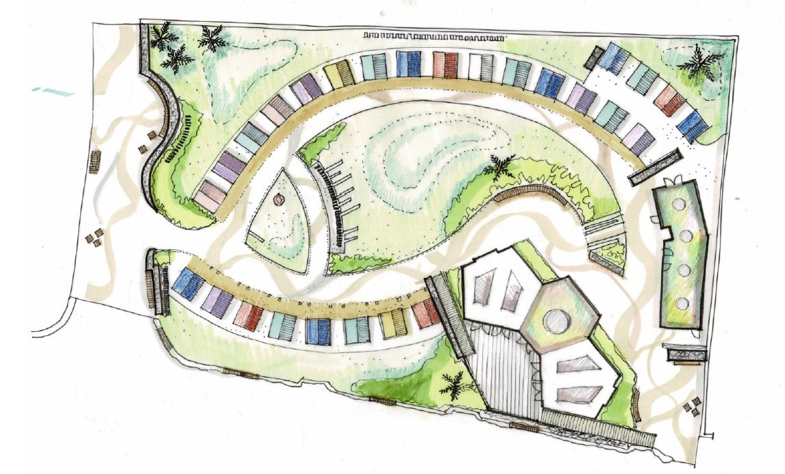
However, with further permissions required before construction could proceed, the project has been delayed by approximately three months. This means that it would not be ready in time for the summer season as hoped and, as a result, we have therefore decided that construction will now get under way in September 2022.
This follows discussions with local businesses, residents and other stakeholders about the likely disruption that construction will cause and a determination not to impact on this year’s summer season and everything the South Seafront has to offer.

Survey of East Suffolk businesses
We are currently looking at the vitality of our town centres and in order to help understand and improve town centres, we need views from local businesses.

One important source of data is capturing the ‘business confidence’ and perceptions of traders in town centres across the district. By establishing the trading conditions of town centre businesses, we can focus on issues of concerns and how to improve them.

All town centre businesses are encouraged to complete the short survey by Friday 28 January at https://destinationresearch.typeform.com/towncentres

Supporting customers to access council services
To ensure residents can continue to access our services in the way that suits them best, our Marina Centre in Lowestoft is open (Tuesdays and Thursdays 10am – 4pm), along with our desks at Woodbridge and Saxmundham Libraries (Wednesdays 10am – 4pm) and at Felixstowe and Leiston Libraries (Fridays 10am – 4pm) – all by appointment only.

The majority of our services are available at www.eastsuffolk.gov.uk and we encourage residents to continue to use these online services wherever possible.

However, anyone with difficulties using these services or who are unable to resolve an issue online, can email or call our Customer Services Team. If still unable to resolve the issue, an appointment can be made for one of our Customer Services locations in person by calling 0333 016 2000.

Residents can also learn how to access our online services and report issues directly, using our new ‘digital receptions’ which are available at the Marina Centre and libraries. Residents should book an appointment and our fully trained Customer Services staff will be available as ‘digital champions’ to help them get online.

Southwold residents to vote on Neighbourhood Plan
Residents in Southwold will be asked whether a Neighbourhood Plan for the town should be used by the Council for future planning applications.

The Southwold Neighbourhood Plan was developed by Southwold Town Council following extensive consultation with the local community and sets out its vision for development to 2036.

Following a six-week public consultation last year, an independent examination has now been completed which found the plan meets all legal requirements, subject to some amendments.

As a result, we have concluded that the Plan should proceed to a referendum incorporating the recommended amendments suggested by the examiner. The referendum will take place on Thursday 3 February and will ask residents to vote on whether we should use the Neighbourhood Plan for Southwold to help determine planning applications in the neighbourhood area.

Details about the referendum and how to vote will be published soon.

For more details about the Southwold Neighbourhood Plan, including the examiner’s report and our statement, go to www.eastsuffolk.gov.uk/planning/neighbourhood-planning/neighbourhood-plans-in-the-area/southwold-neighbourhood-area/

Surveys and consultations
We are currently running one consultation and, as always we want to encourage participation as feedback from people in East Suffolk is invaluable and helps us ensure we’re making the right decisions for our communities.

- The draft East Suffolk Cycling and Walking Strategy
Consultation on draft document which provides a district-wide shortlist of cycling and walking infrastructure opportunities. The strategy aims to encourage greater use of sustainable forms of transport, reduce contributions to climate change, support the growth of the tourism industry, and to improve the health and wellbeing of residents by ensuring more trips to work, school, leisure, day-to-day errands, or public transport hubs, such as train stations or park and ride sites, are accessible by bike or on foot. Once adopted, this strategy will replace the Waveney Cycle Strategy (2016) and will cover the whole of the district. People can have their say on the consultation until 10 January at https://storymaps.arcgis.com/stories/cbc57e4a9cc24eeea7d174fb34b1bf0e

Social media
We keep our communities up to date in a variety of ways and social media has an important role to play. Please follow us and share our posts with your audiences!
Facebook: www.facebook.com/eastsuffolkcouncil
Twitter: https://twitter.com/EastSuffolk

Your District Councillors are-:
Cllr Colin Hedgley (Colin.Hedgley@eastsuffolk.gov.uk)
Cllr Tony Fryatt. (Tony.Fryatt@eastsuffolk.gov.uk)

